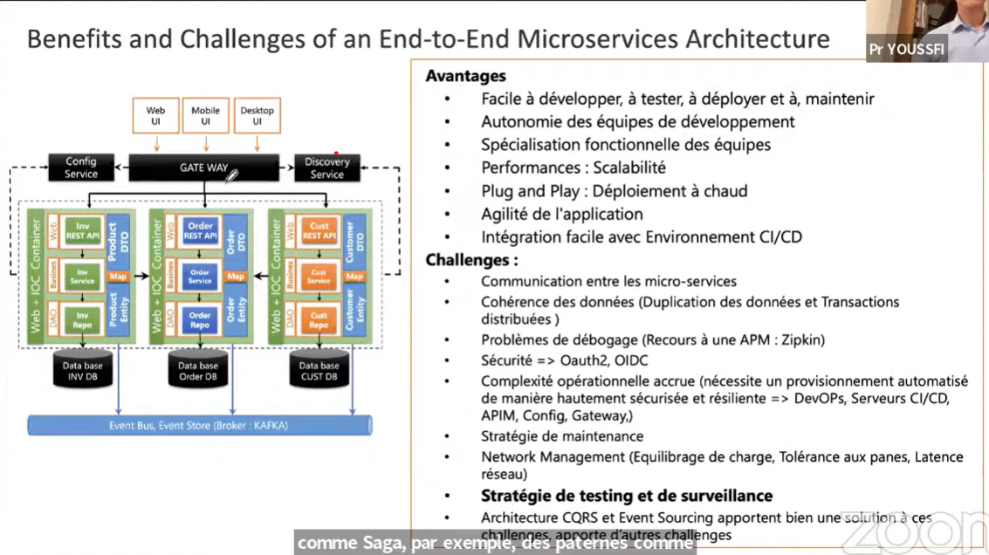

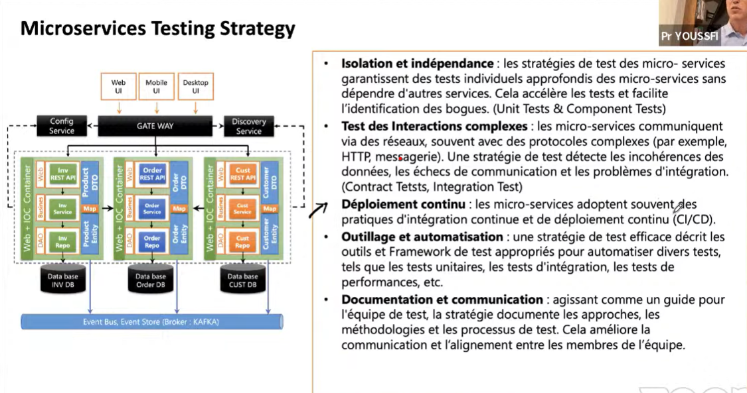

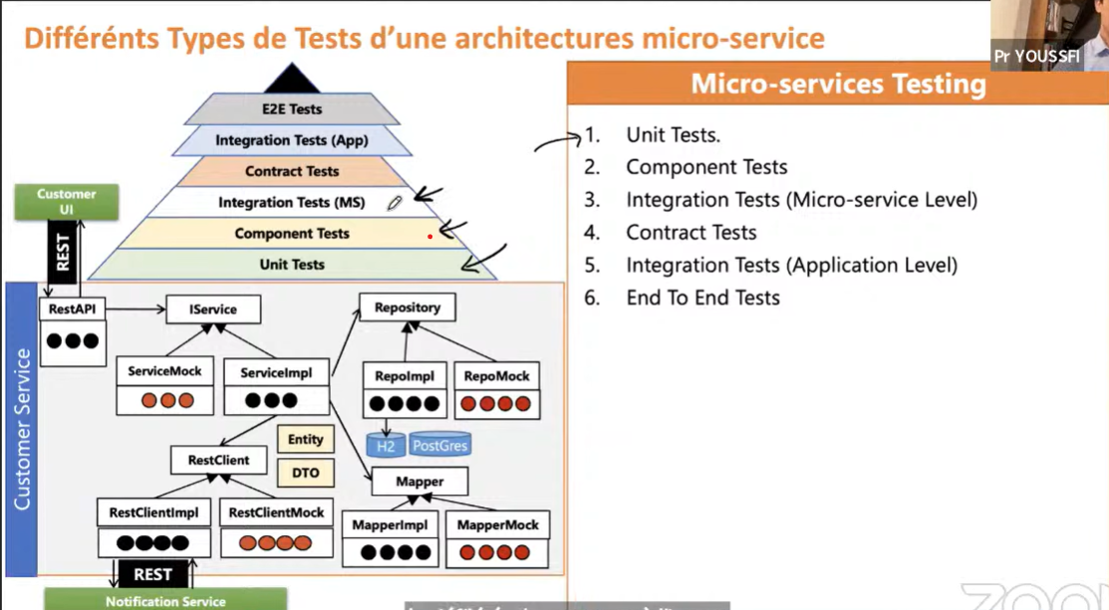

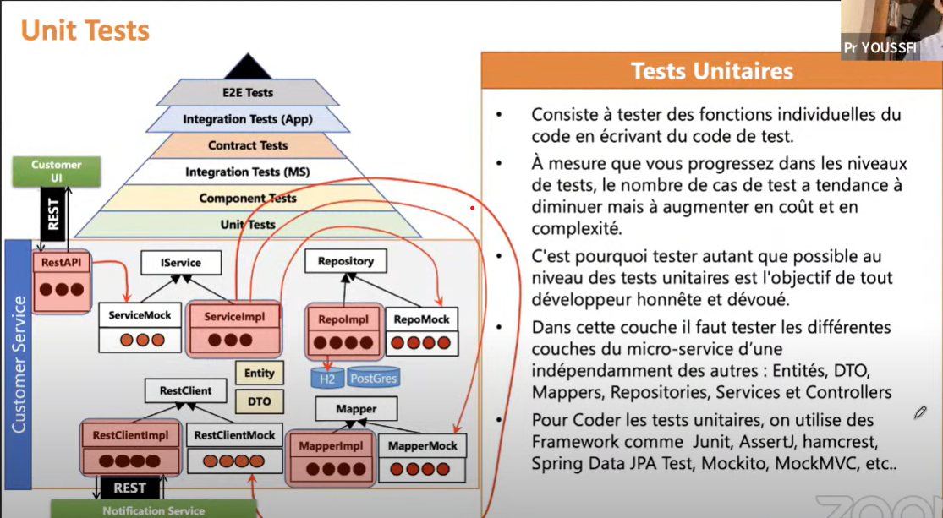

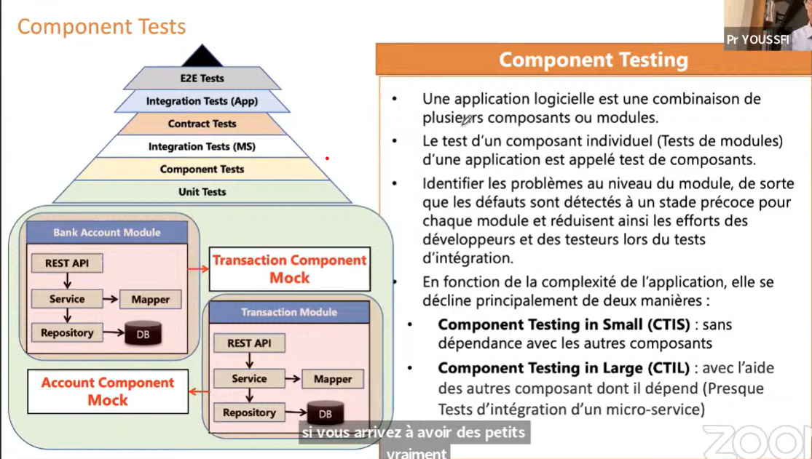

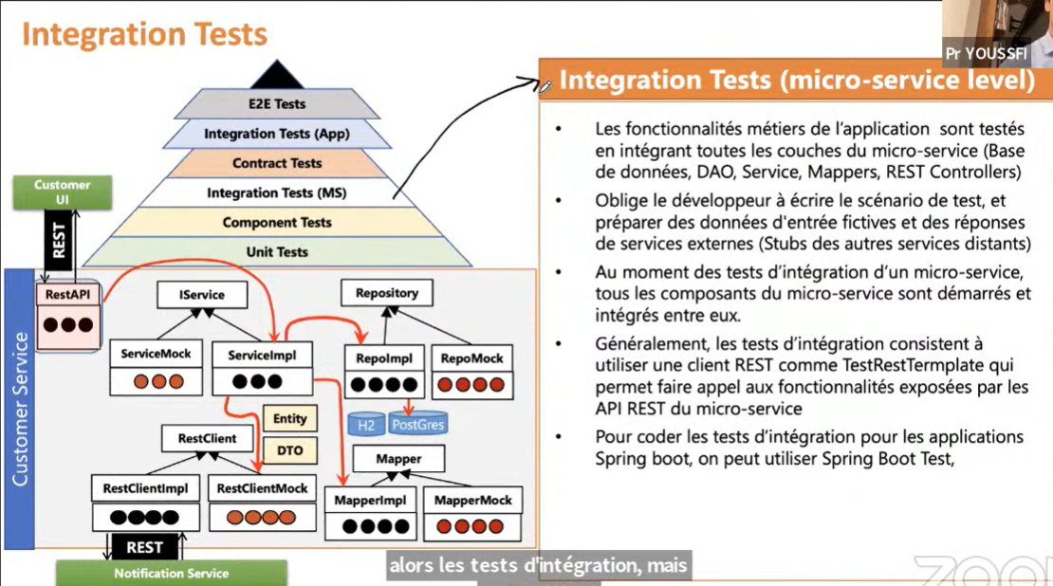

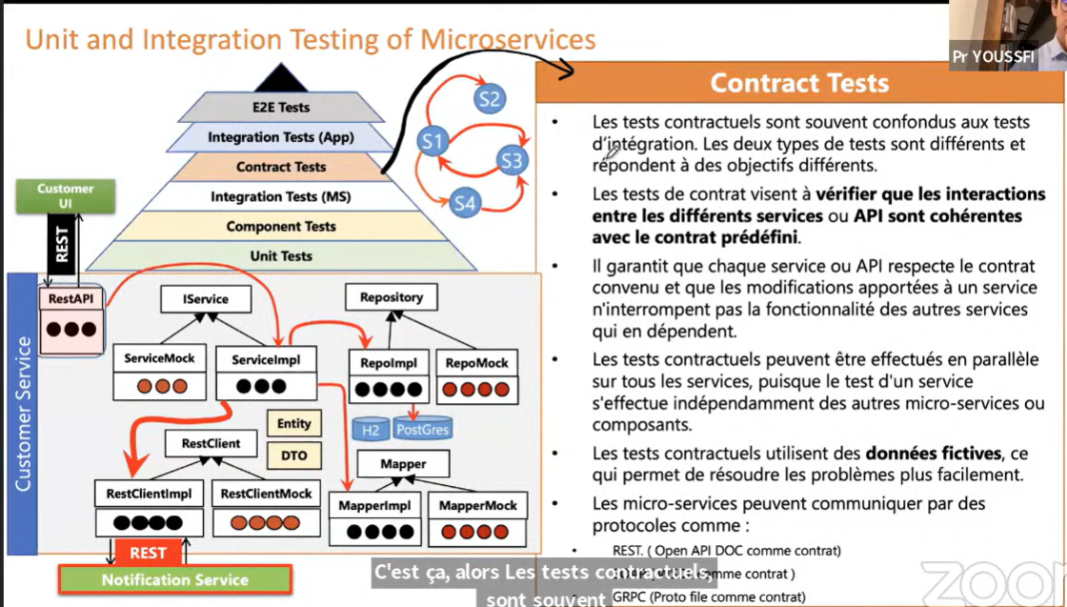

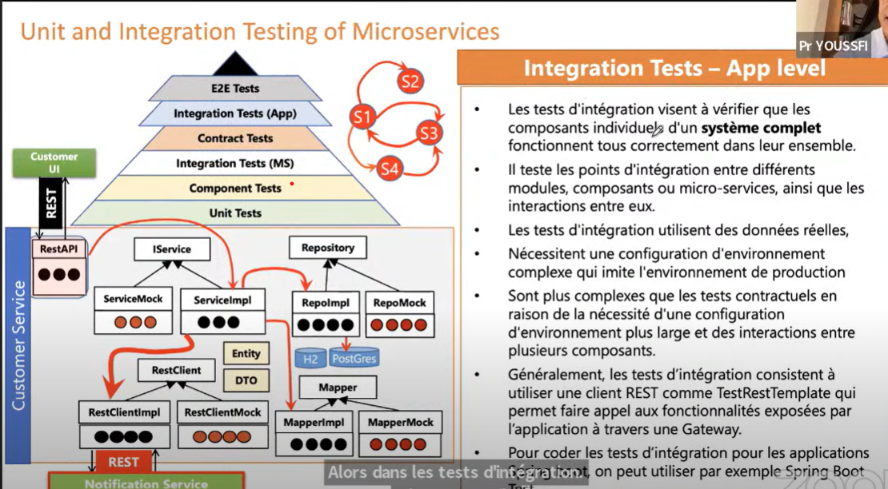

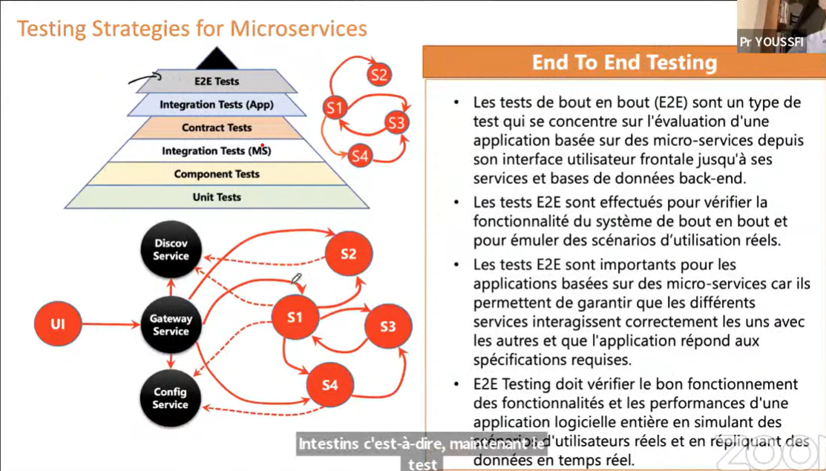

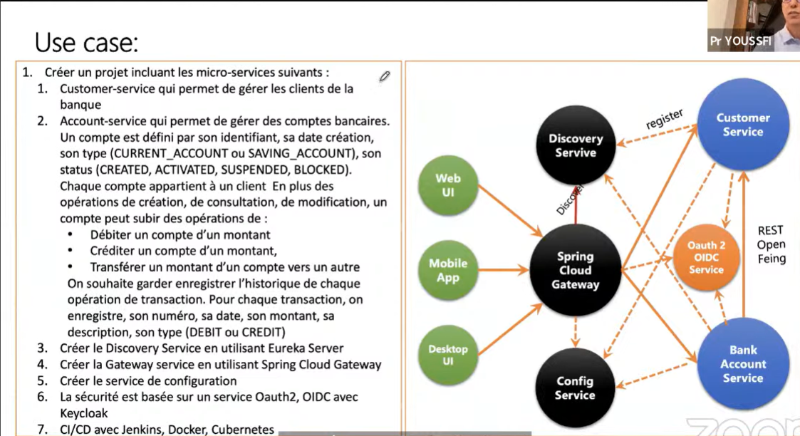

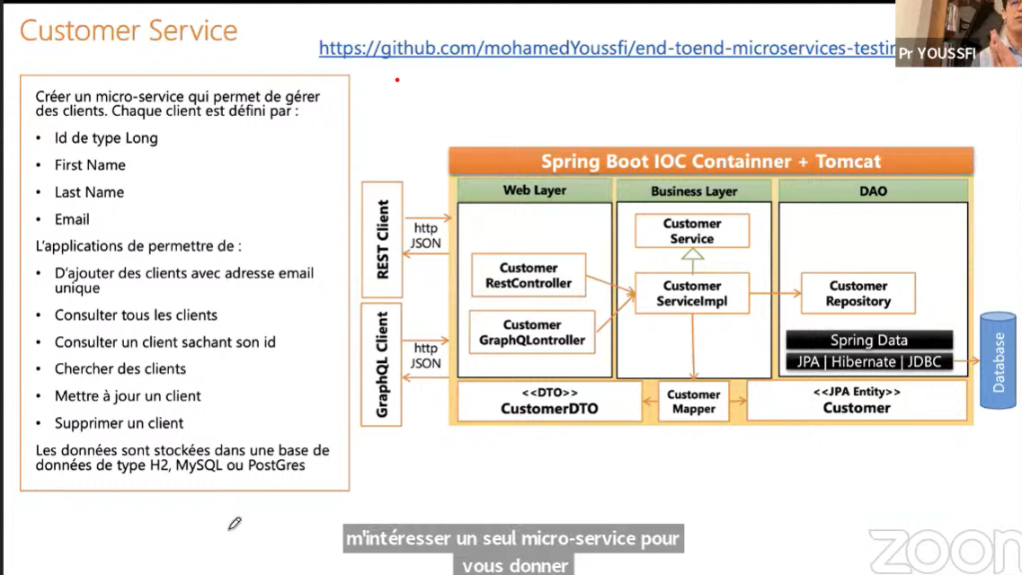

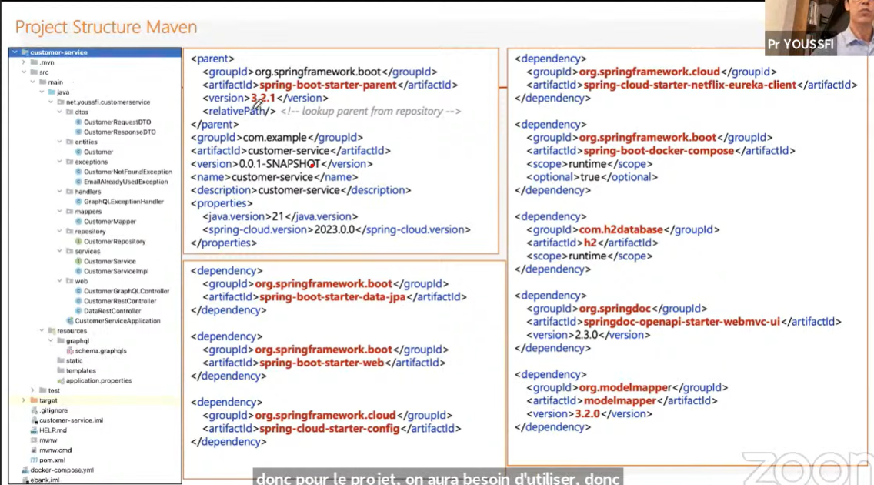

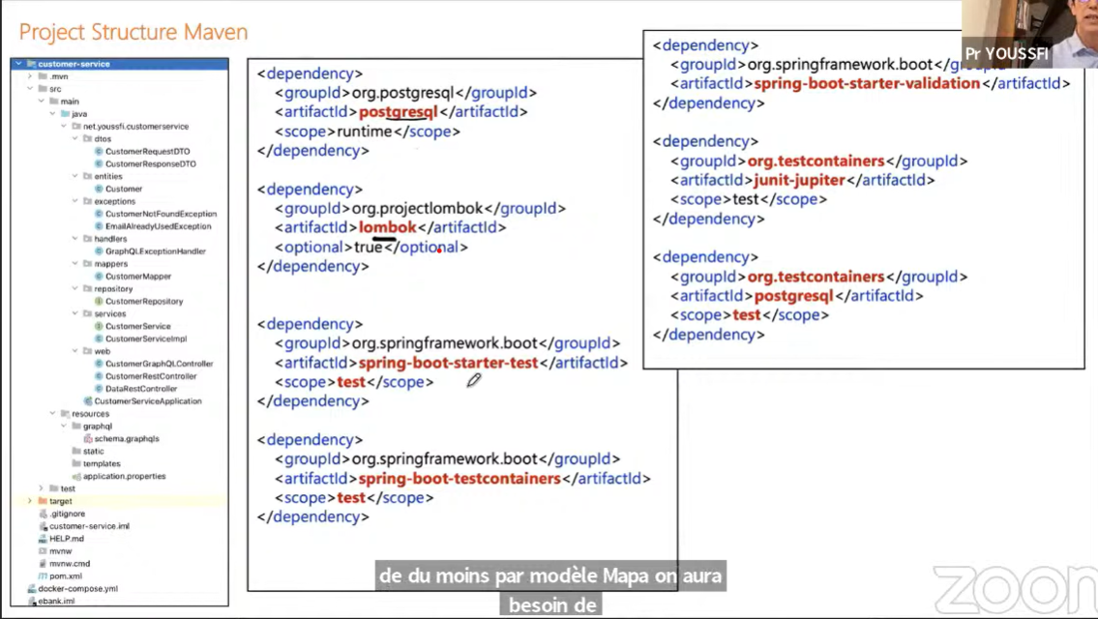

* Creation a simple Maven project in IntelliJ (webinar-ms-e2e-testing)
* Inside this Maven project, create a module for customer microservice:
  + Click on the main project name (webinar-ms-e2e-testing), select New > Module > Spring Initializr (Name: customer-service) > Next
  + Spring boot (version): 3.2.2
  + Dependencies:
    - Web | JPA | Lombok | Config Client | Eureka Discovery Client | Testcontainers | Docker compose support | Validation | PostgreSQL Driver | H2 |
  + Packages:
    - dto | entities | exceptions | mapper | repositories | services | web
    - Create the “Customer” entity
    - Create the “CustomerRepository” interface
  + Configure the “application.properties”, and “compose.yaml” files
    - **NB**: Move docker’s compose.yaml file at the root of the project (don’t keep it in the module)
    - **sudo lsof -i** tcp => display all process using tcp protocol
    - **sudo kill -9** PID => to terminate the process with id PID
  + Create Unit test for a class. Within the class “**Alt + Insert**” > Test
  + CustomerRepositoryTest:
    - Use class level **@DataJpaTest** annotation (start Spring data context when running this test)
* Compose.yaml generated by spring initializr and updated

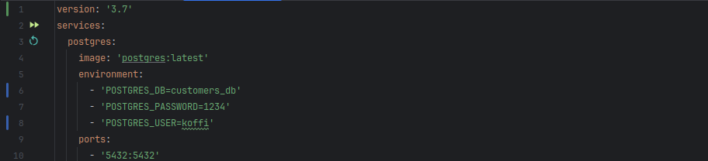

**application.properties**:

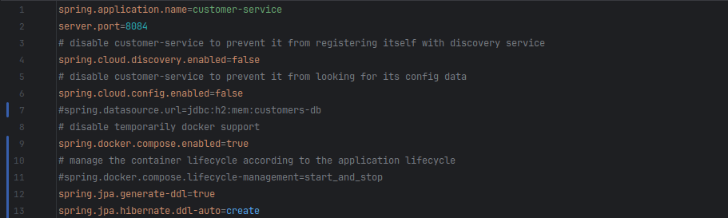

$ **docker exec -it** <container_name> **psql -U** <POSTGRES_USER> **-d** <POSTRGES_DB>

**Example**: $ **docker exec -it** webinar-ms-e2e-testing-postgres-1 **psql -U** koffi **-d** customers_db

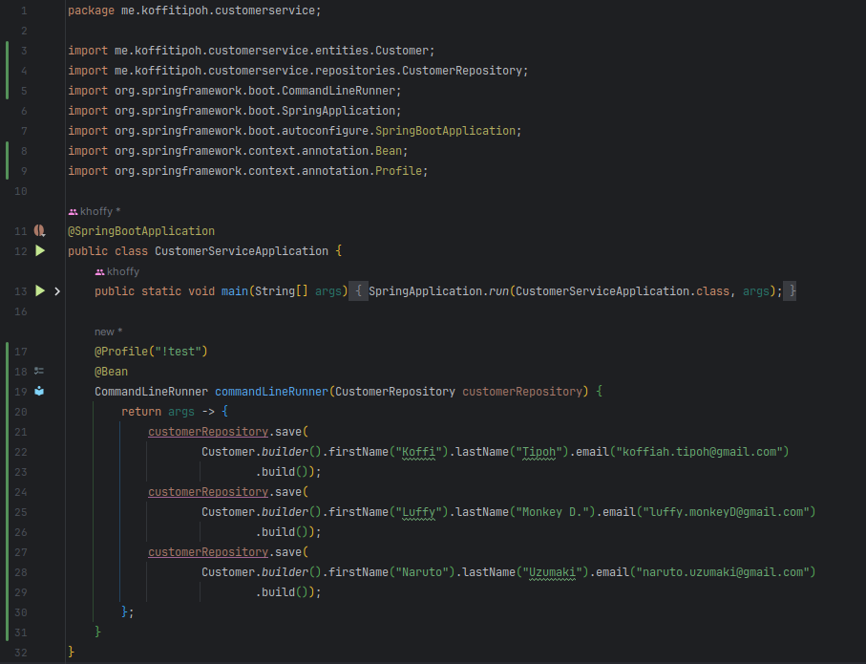

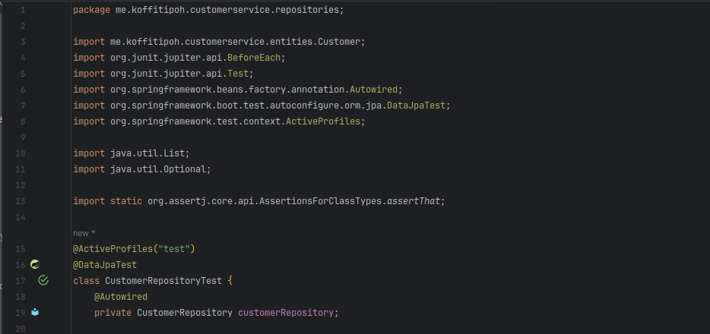  
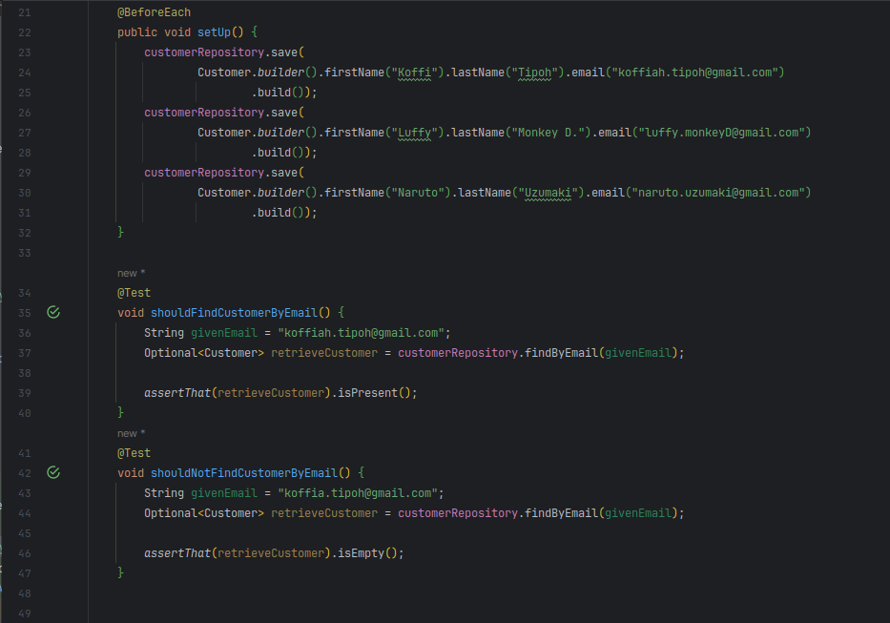

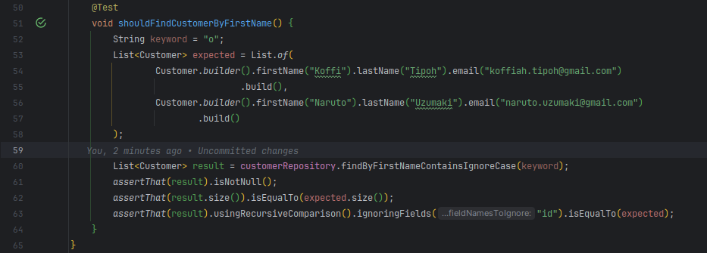

* + Running tests with containers

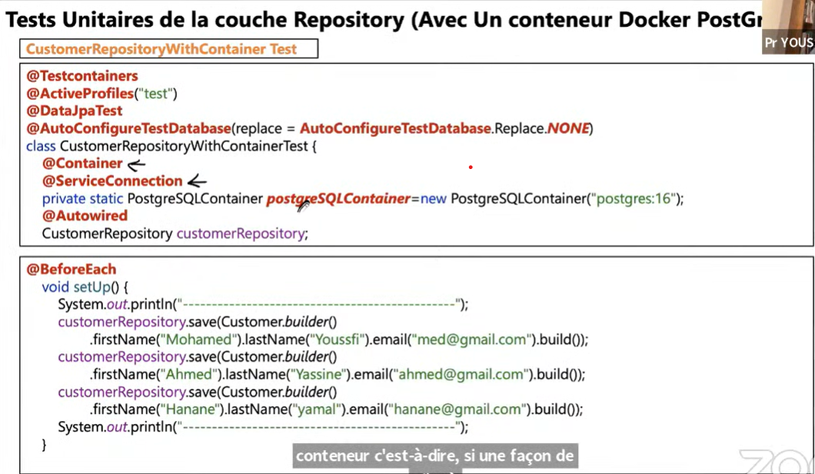

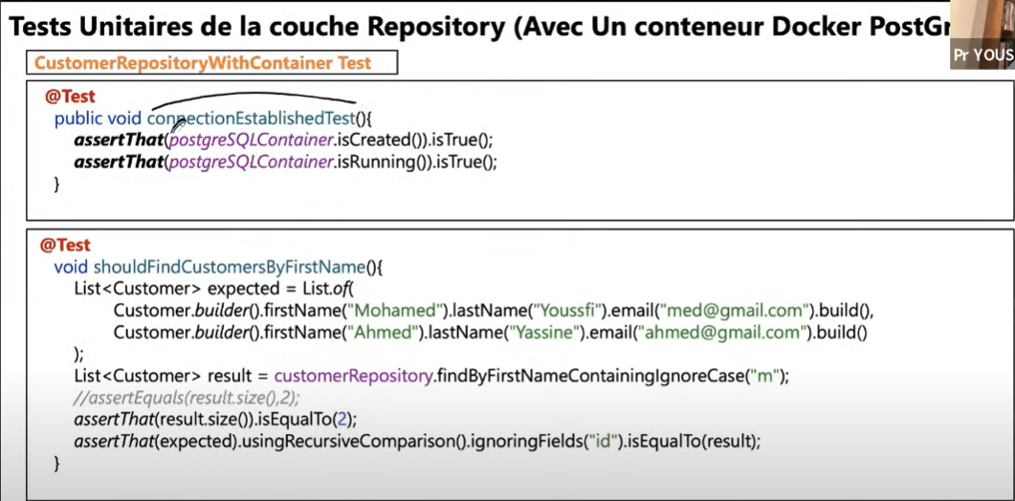

* Let’s create a mapper. To do so, we need the **ModelMapper**’s dependency:

<!-- https://mvnrepository.com/artifact/org.modelmapper/modelmapper -->

<dependency>  
 <groupId>**org.modelmapper**</groupId>  
 <artifactId>**modelmapper**</artifactId>  
 <version>3.2.0</version>  
</dependency>

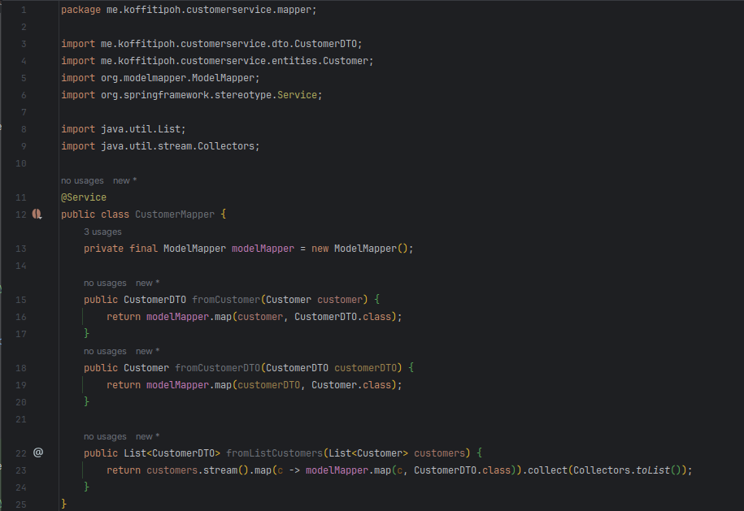

* + Let’s create a test class for the mapper

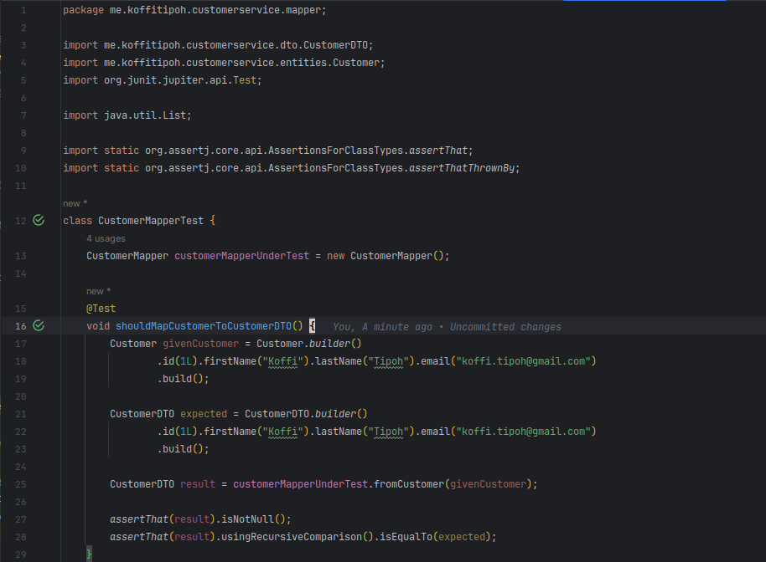

**+++++++++++++++++++++++++++++++++++++++++++++++++++++++++++++++++++++++++++++++**

Another version of **compose.yaml** (pgAdmin integration)

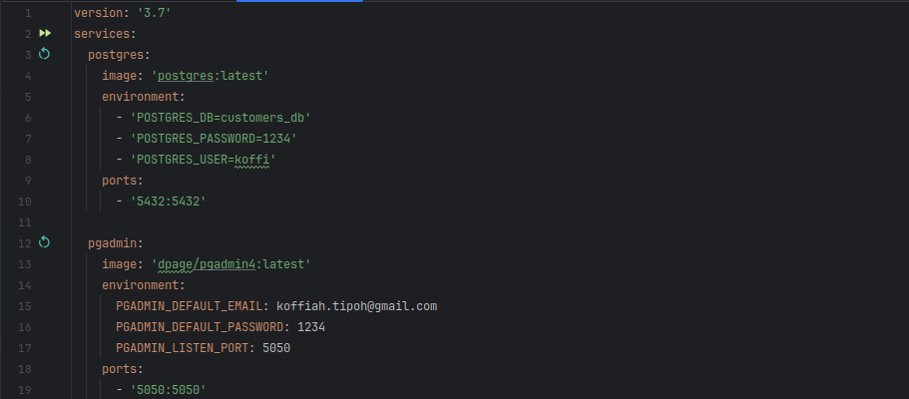

* Launch PgAdmin at <http://localhost:5050>

Provide email/password to connect > click on “Servers” > “Register” > “Server” > Name: <db_name>

“Connection” : Host name/address: **($ docker inspect** <db_container_name> **| grep IPAddress**, to get the database ip address), then provide the database username/password

**+++++++++++++++++++++++++++++++++++++++++++++++++++++++++++++++++++++++++++++++**

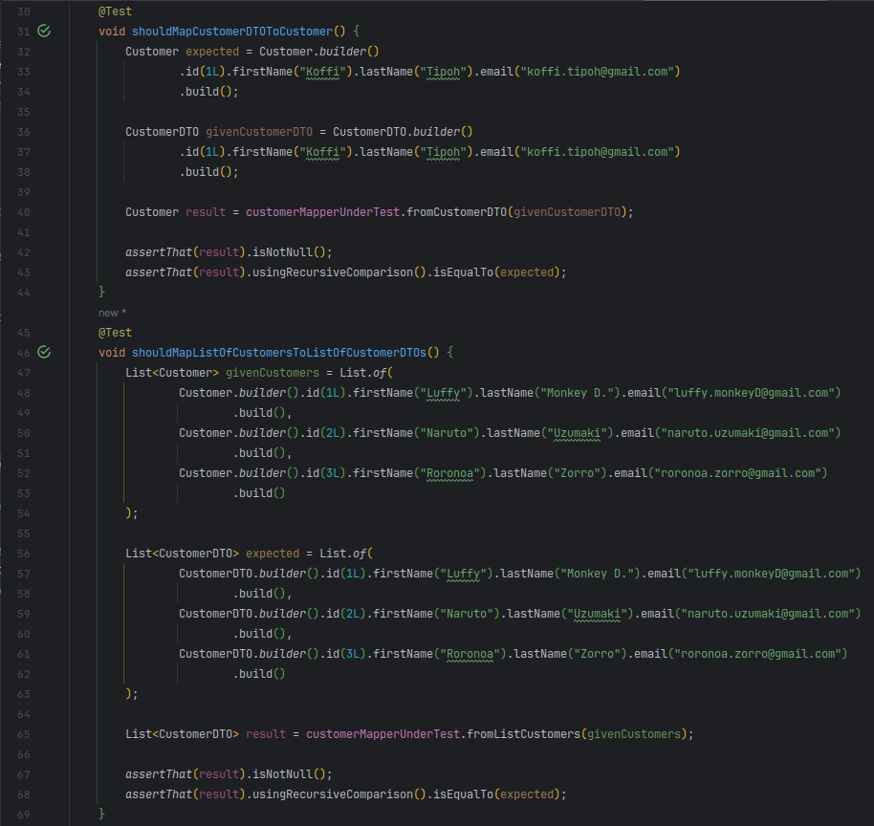  
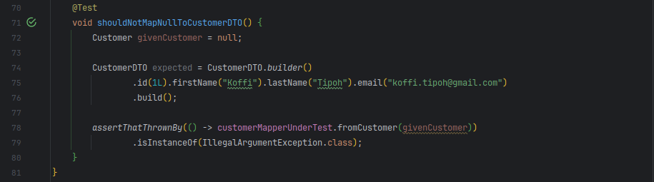

* + Service layer

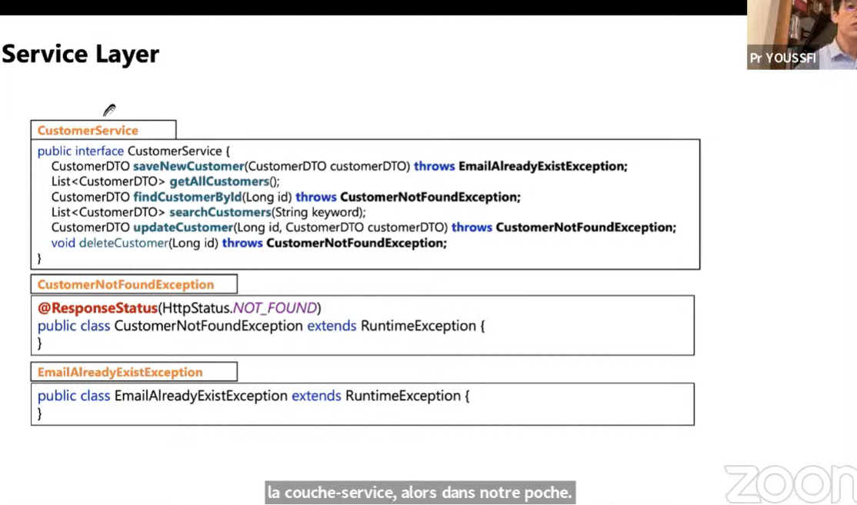  
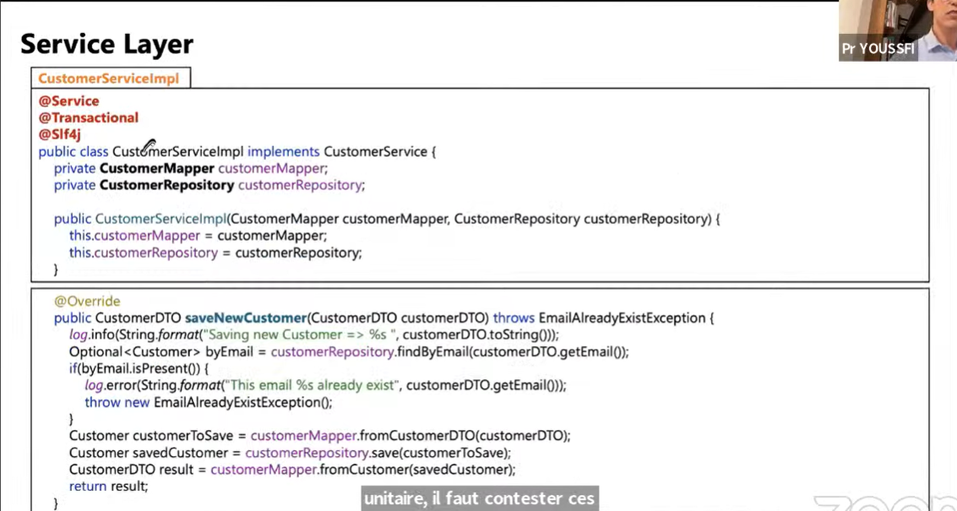

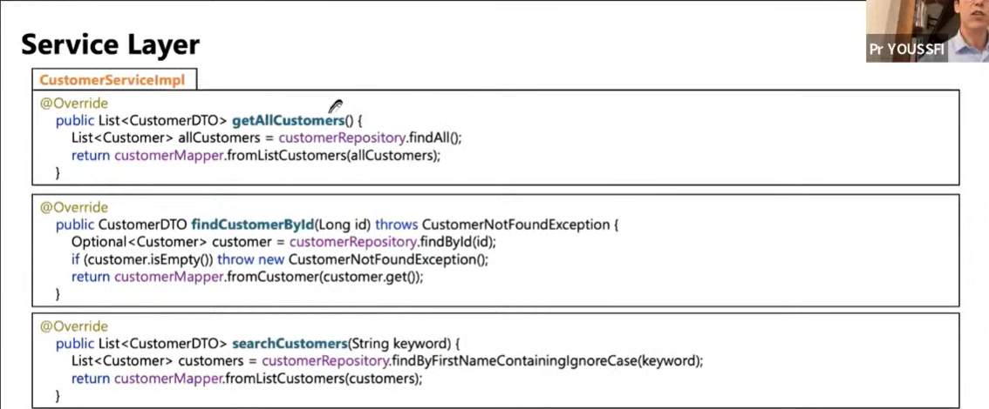  
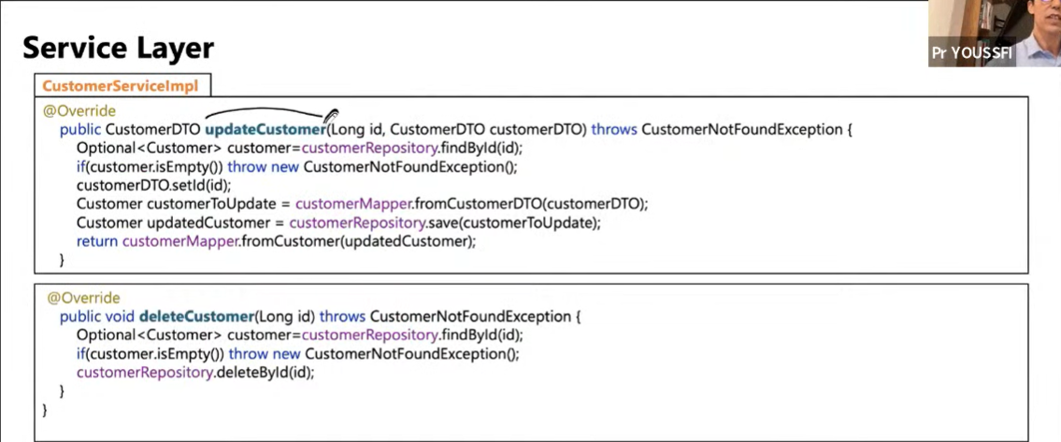

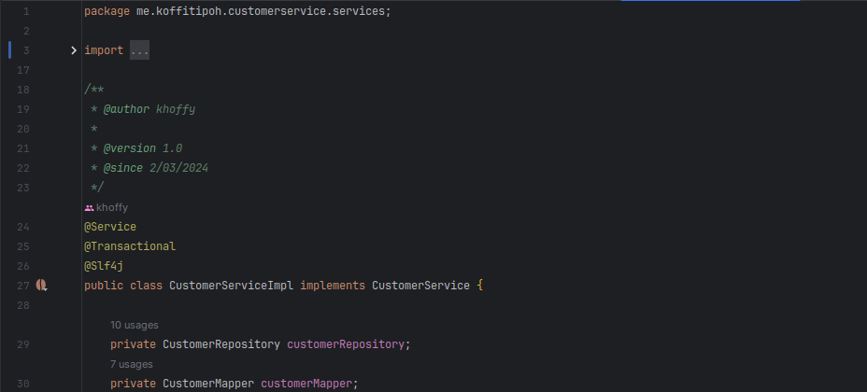

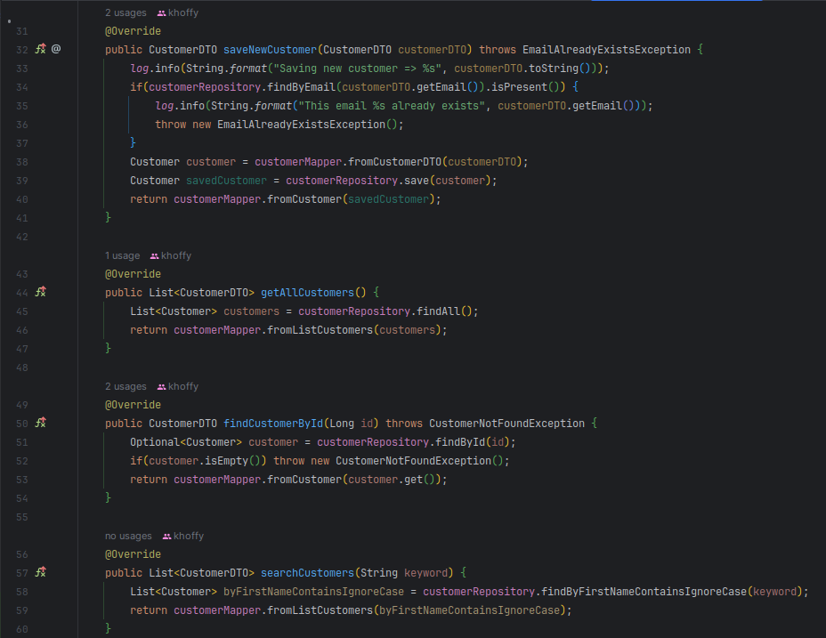  
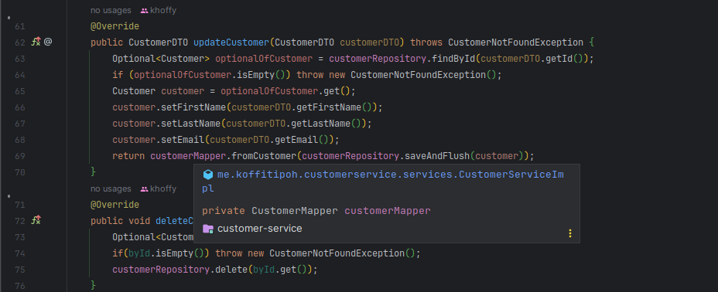  
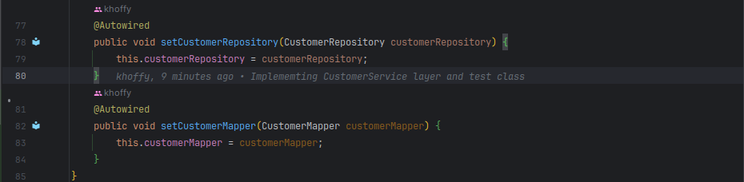

* + Service layer Tests

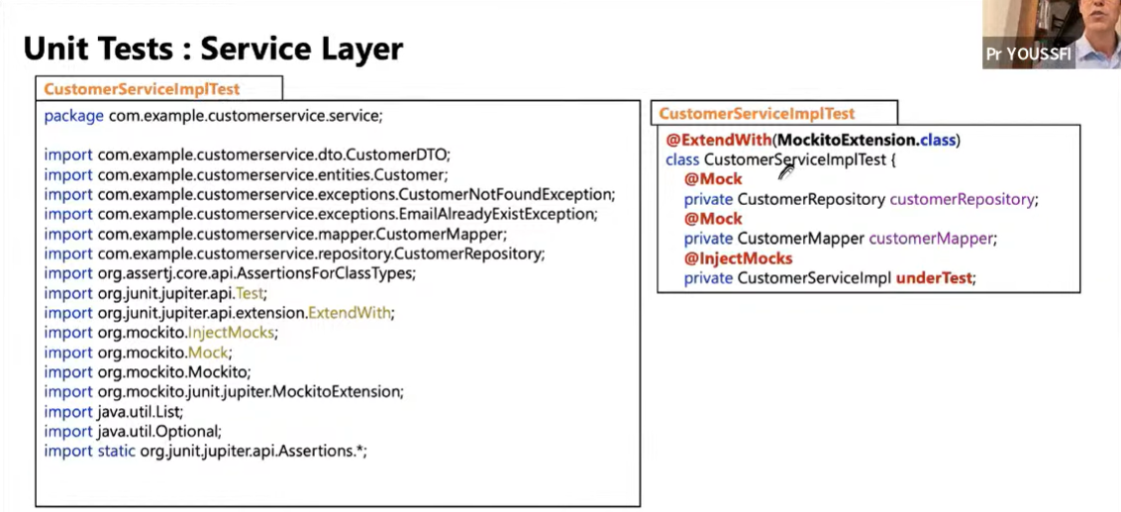

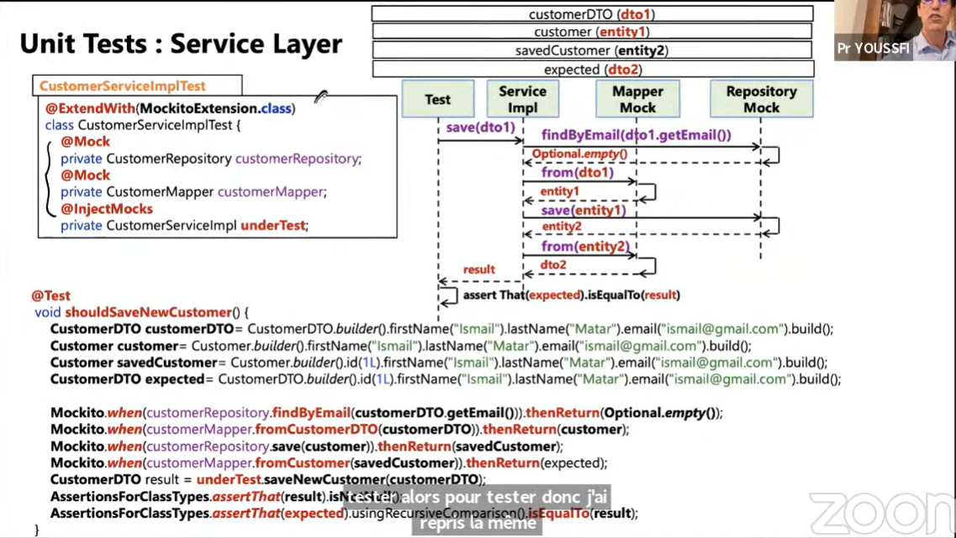

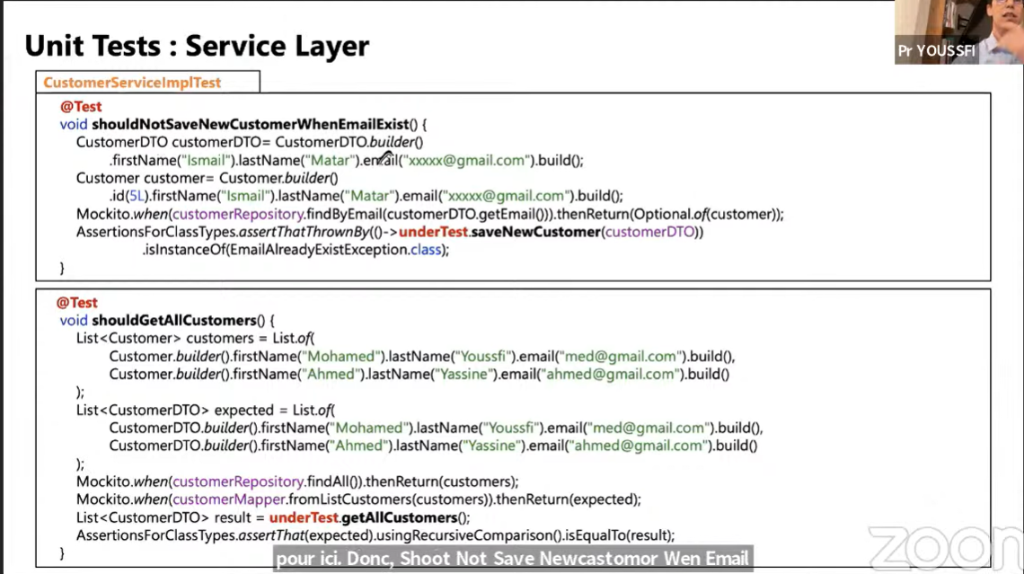

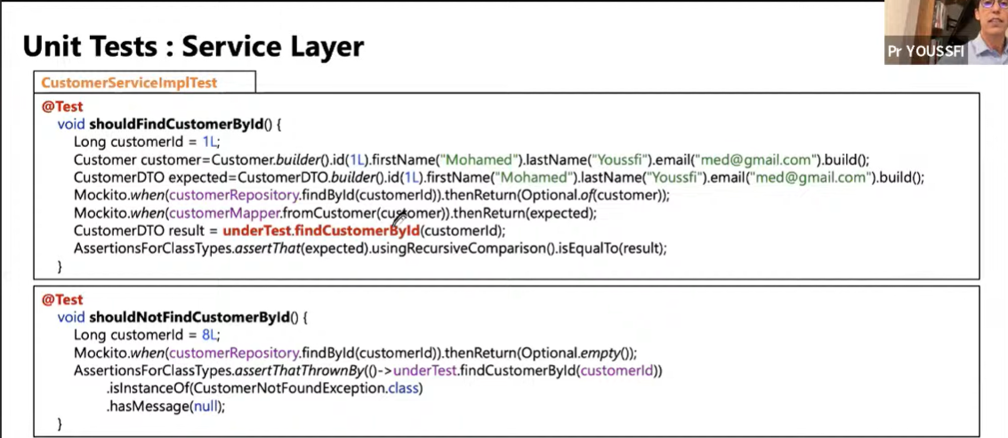

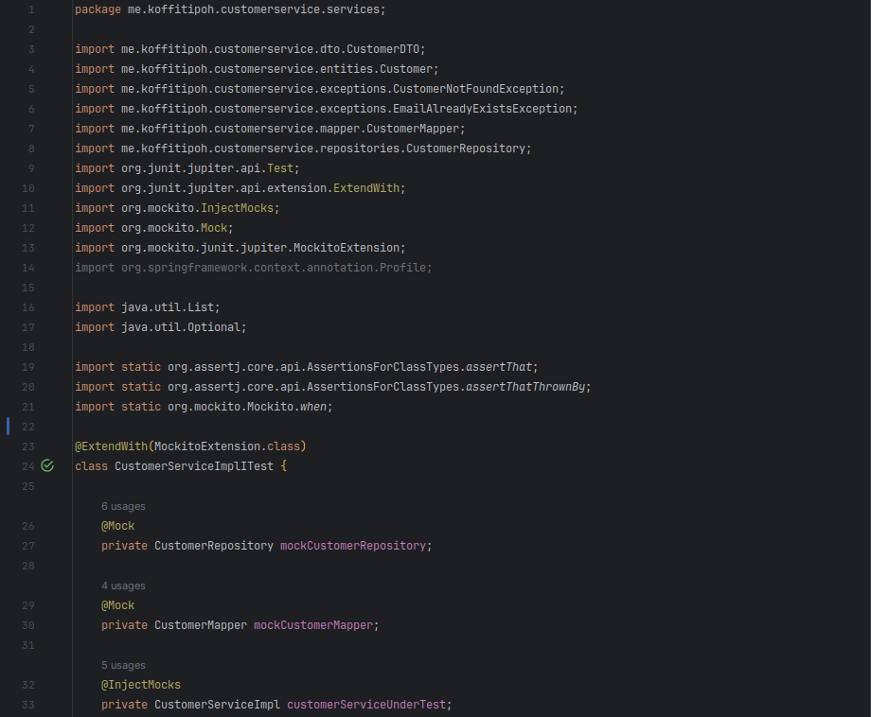

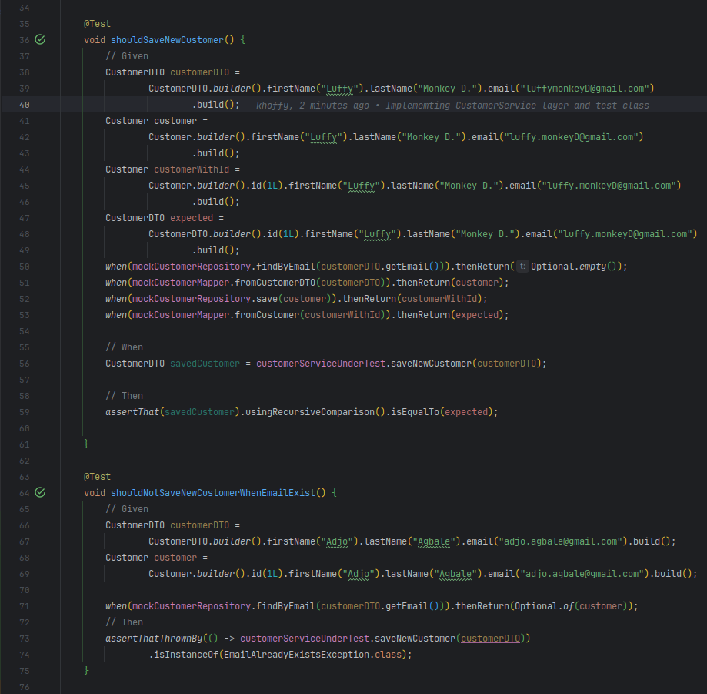  
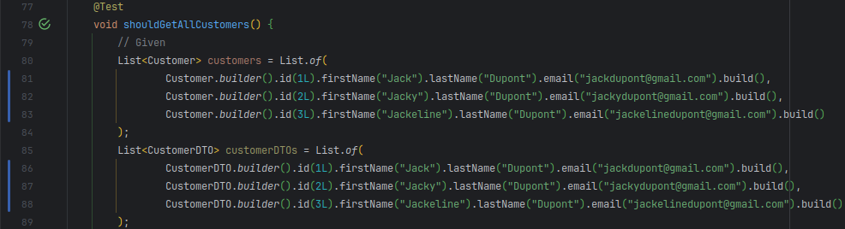

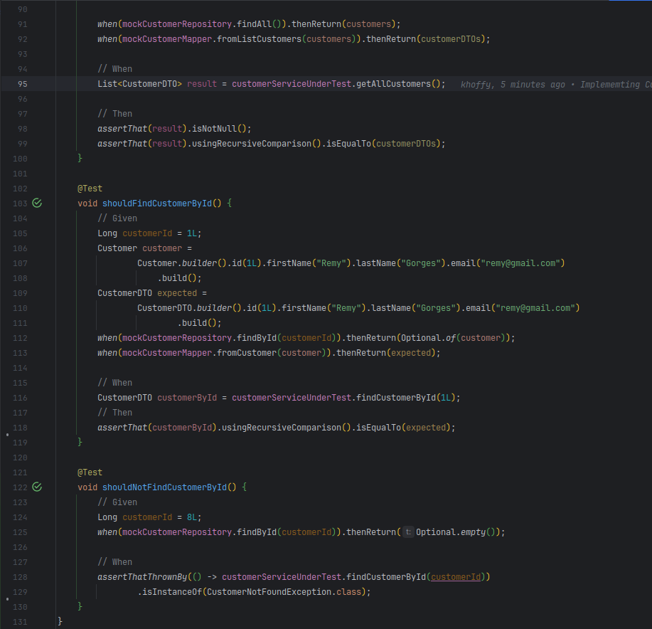

* + Web layer

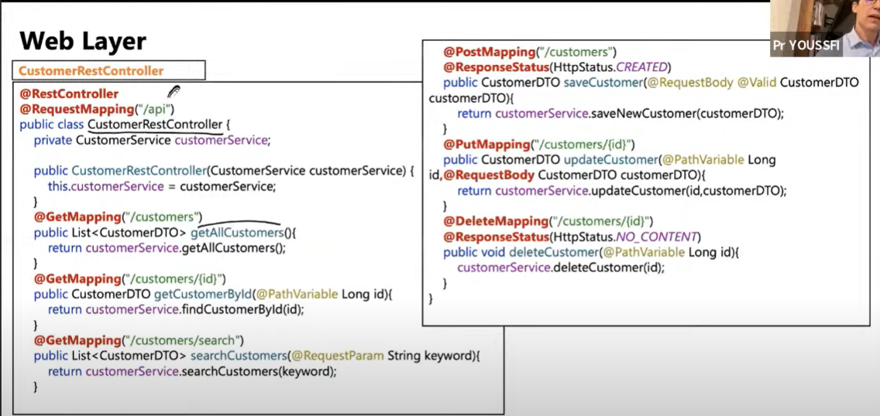

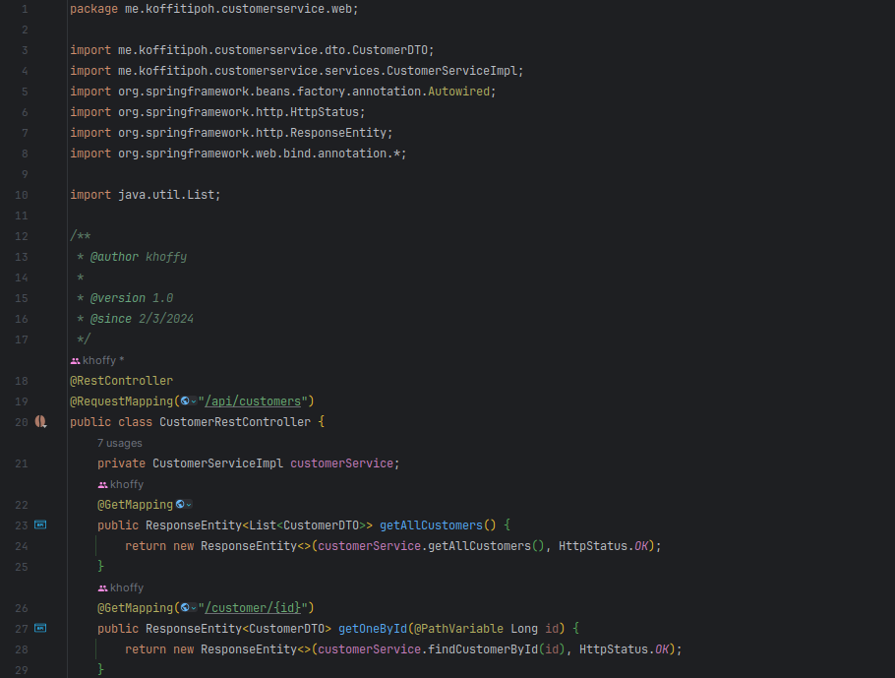

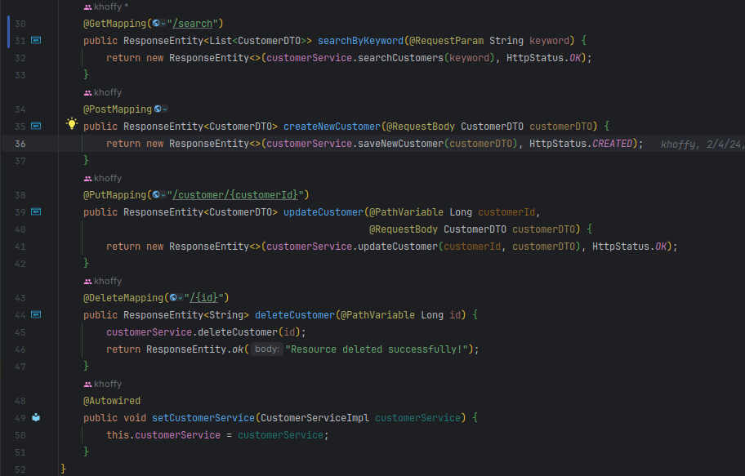

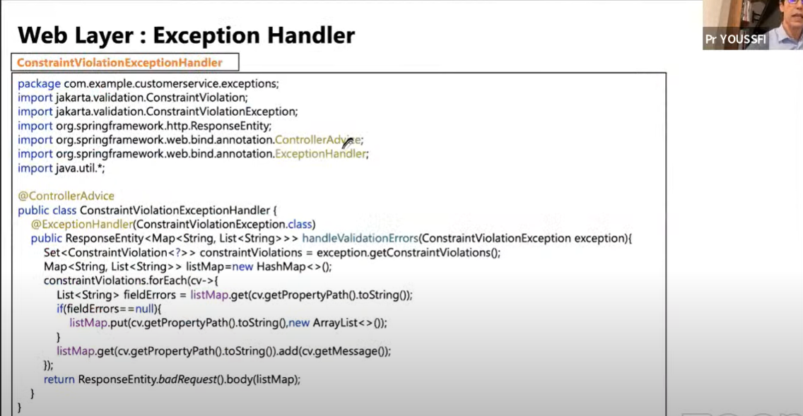

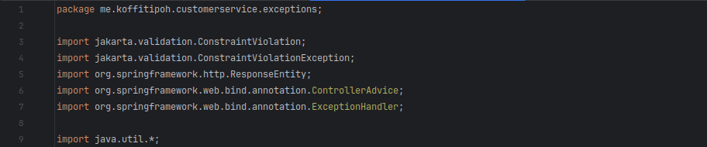

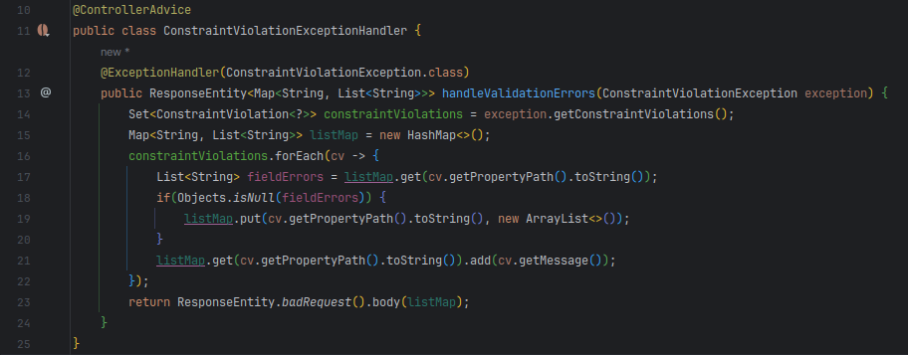

* + Web layer Tests

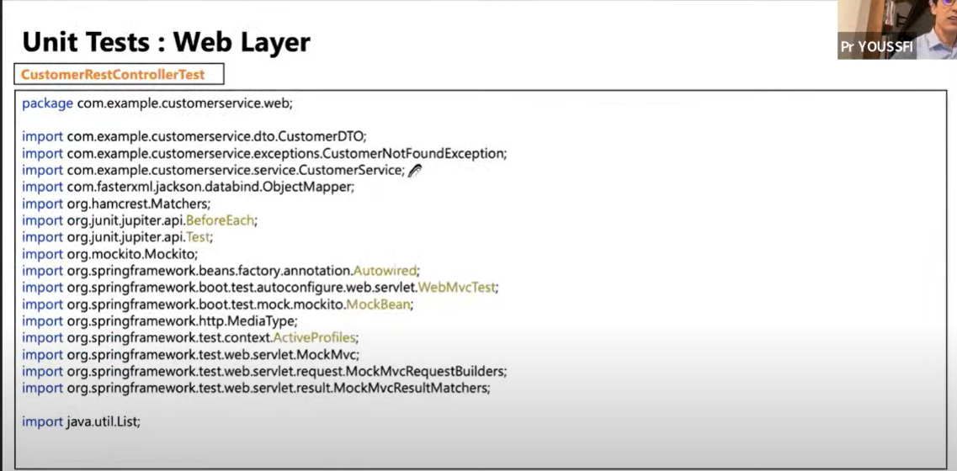

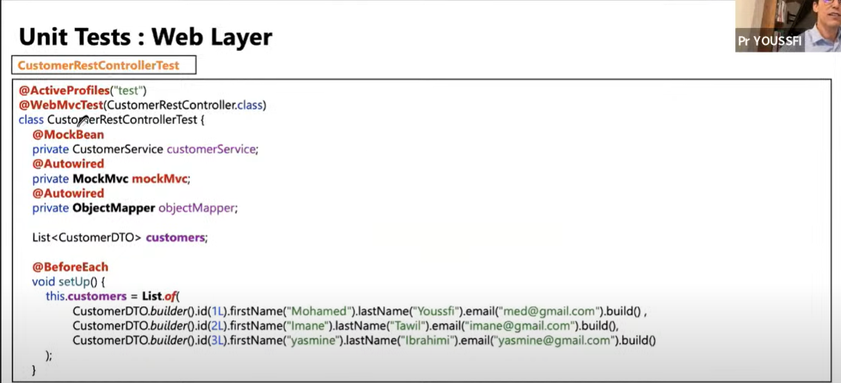

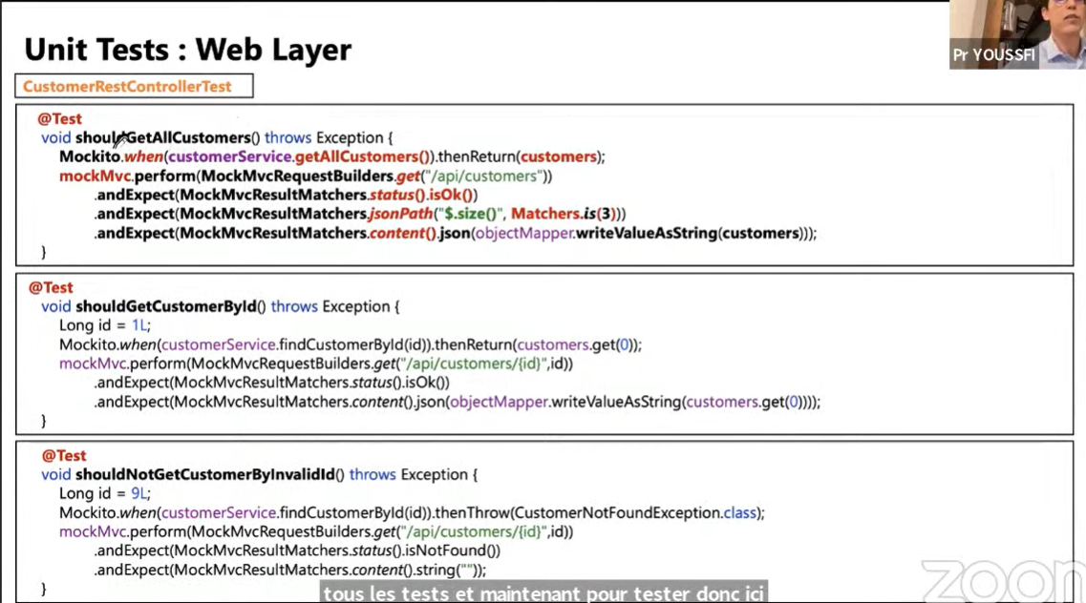

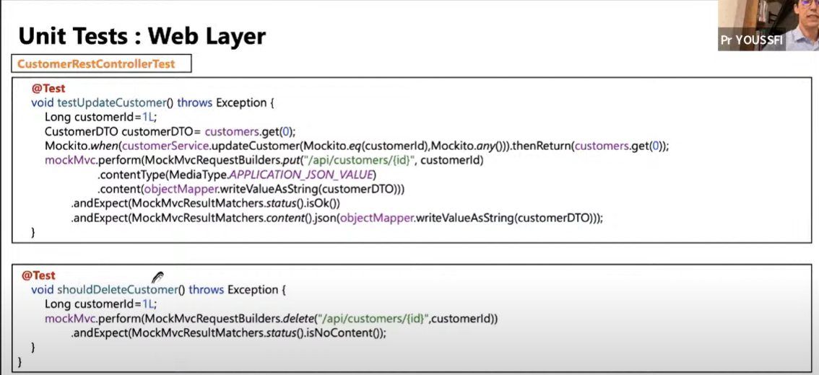

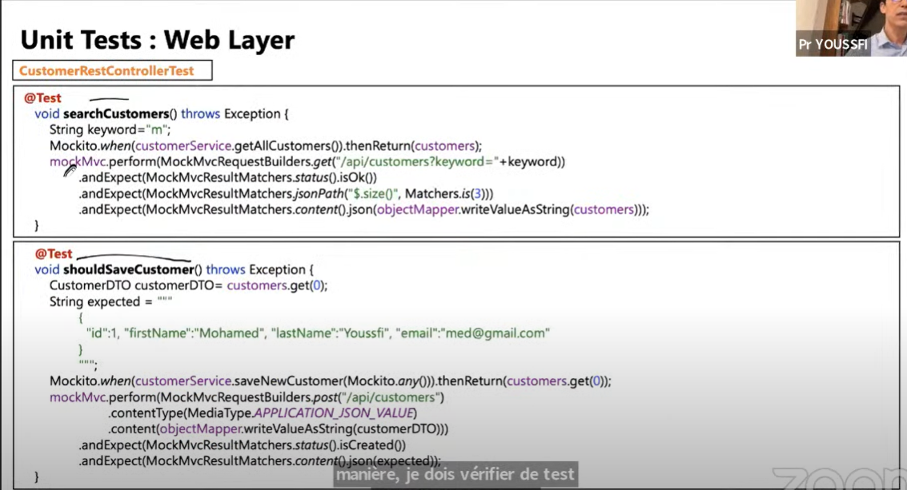

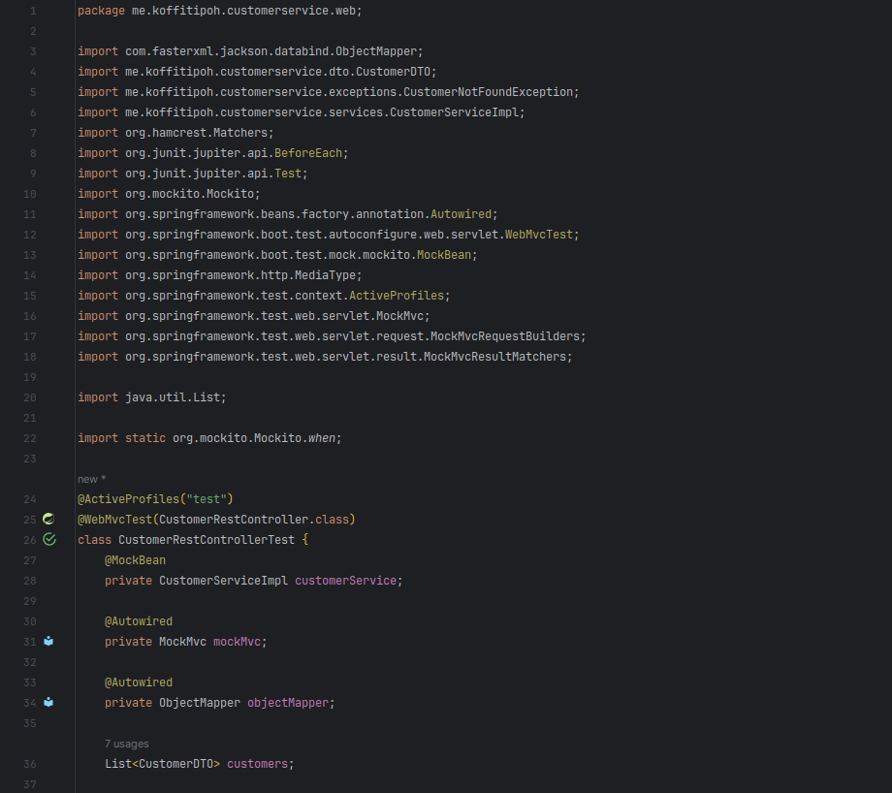  
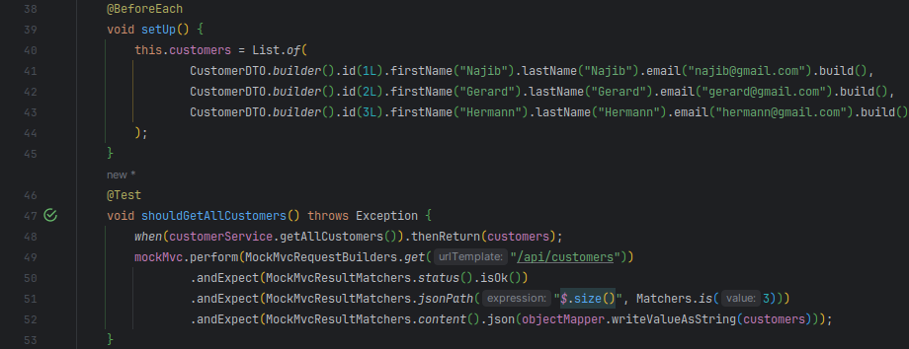

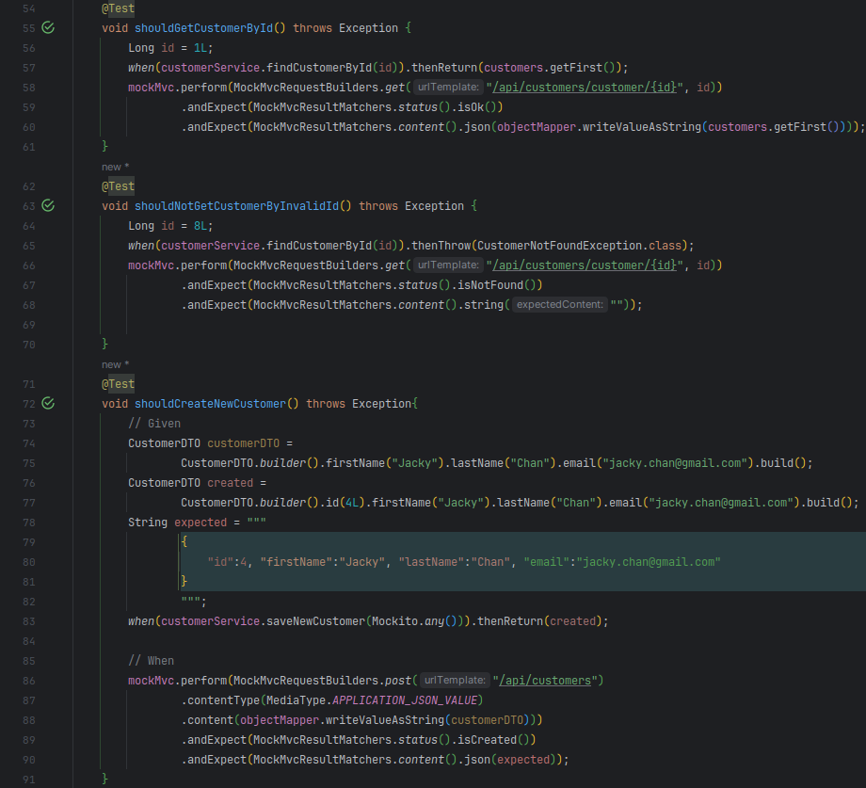  
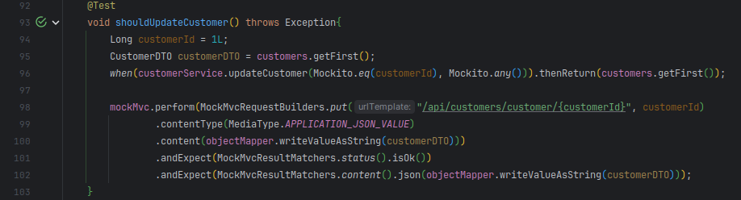  
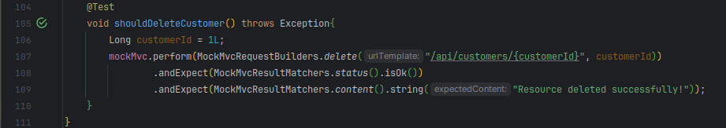

* + Micro-service Integration Test

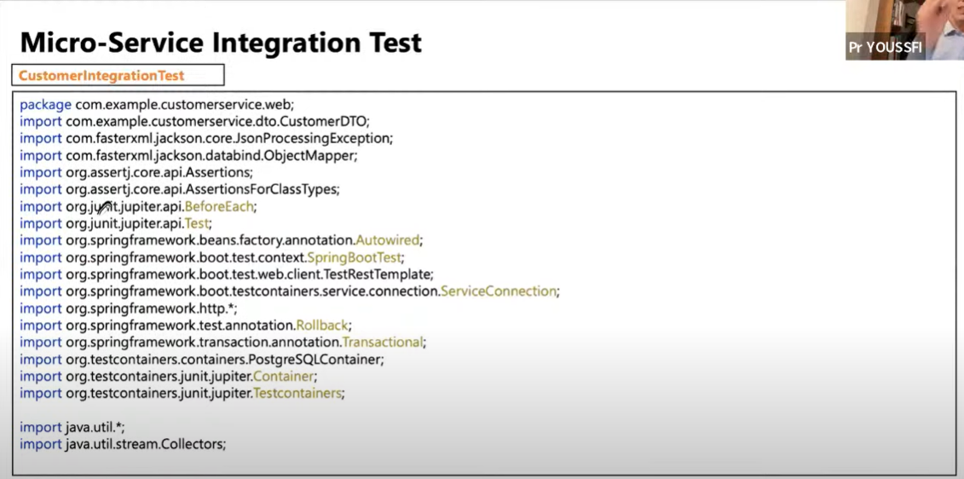

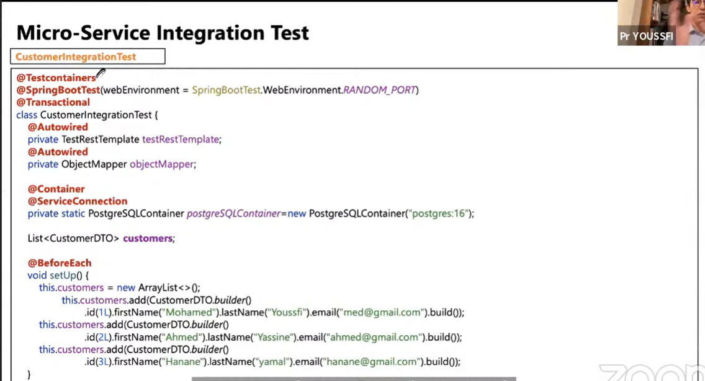

$ psql -U <local_machin_username> -h localhost postgres

